INDIVIDUAL RANGE CARD
Made out by______________________ Date ________________________________



N
GR of Trench______________________________ Method of obtaining Range _______________________
Section________________ Team ___________________Weapon type _____________________________
L Arc ________________________________ R Arc___________________________________________
Opening Fire Policy ________________________________Signal _________________________________
FPF SIGNAL ____________________________ FPF Location __________________________________
Location of Claymores Trip flares

Target # / Description | Range | Bearing | Grid | Remarks
1.
2.
3.
4.
5.
6.
7.
8.
9.
10.
11.
12.
13.
14.
15.

Notes / Remarks

Wpn | Rge | Basic Ld | Ammo type | Rate of Fire | Remarks
C7 | 300m | 350 rds | Ball, tracer | 5 rds/min (normal)  20 rds/min (rapid) | Rng 600 M SEC Fire  Tracer burnout 600
C9 | 600m | 800 rds | Ball, tracer | Sustained 750 to 1000 rds/min
C6 | 800m light  1800m SF | 1760 | Ball, tracer | Normal  110rds/min.  Rapid  220rds/min | Tracer burnout 1200 M
50 cal | 800m – 1200m |  | Ball  Pers. 2000m  Tracer  C44 AP-Anti BMP 800m | Normal  40 rds/min  Rapid  100 rds/min | APC font 400  Side 600
M72 | 125m | 3 trk veh  1 whl veh | HEAT | Shot disposable
84mm | 300m  800m |  | HEAT  HEAT RAP | 4-5rds/min | HEAT 300 Moving  400 Stationary  RAP 600 Moving  800 Stationary
C-16 | 2000m direct |  | HEDP  TP-T  ABM
Lav/  Coyote  25mm | 3000m | 2400 rds | HEI-T  APDS vs APC | 1 rd/min
60mm Mortor | W/bipod  25-2200m  w/o bipod 100-700 |  | HE  SMK WP  SMK RP  ILLM | Rapid  25 rds/min | Hand 800  Bipod 2200
Claymore | 50 –100 m |  |  |  | 60 ° Arc from the front
M-67 FRAG | 25-35 M |  |  |  | Fuze 4.5 sec

Priority of Work  a. establish sentries, standing patrols and/or OPs;  b. site weapons;  c. establish comms other than radio;  d. clear fields of fire and stake arc markers;  e. confirm or adjust the established track plan;  f. draw range cards;  g. dig Stage 1 and 2 battle trenches (see annex A);  h. set out trip flares, claymores and anti-tank mines (mine necklaces) across high speed approaches;  i. dig trenches to Stages 3 and 4;  j. construct obstacle;  k. prepare alternate or dummy positions;  I. extend trenches to Stages 5 and 6; and  m. establish latrines, refuse pits and administrative areas. | Routine “Must have’s”  Stand to / clearance patrols (first light)  Ablutions  Clean weapons and equipment  Section commander inspections  Orders Group or briefings  Improve position / Camoflague  Patrol sweeps area  Standing patrols deploy  Vehicle maintenance  Stand to / clearance patrols (last light)  Personal administration

Trench Construction  Stage 1 - Shell Scrape. A shell scrape is 2 metres long, 1 metre wide, sufficiently deep for protection while in the prone position, and is oriented towards the enemy. It is dug when in contact with the enemy or when the position will not be further developed (e.g. during a hasty defence) (Figure 7-6). If further development is planned, the side of the shell scrape is oriented towards the centre of the arcs of fire.  Stage 2 - Fire Trench. A fire trench is excavated 1.6 m long, 0.75 m wide and 1.4 m deep; or at least arm pit depth.  Stage 3 - Shelter Bay OHP. The shelter is developed from the shell scrap or by enlarging either end of the fire trench by 2.4 metres in length and 1.2 m in depth. Revetment is then added and covered with 0.5 m of packed soil.  Stage 4 - Revet Fire Trench. Revet the fire trench and dig out an elbow rest 0.25 m deep and 0.45 m wide. This serves to lower the profile of the occupants when firing their weapons.  Stage 5 - OHC. OHC is added to the fire trench.  Stage 6 - Improvements. Ammunition bays, grenade traps, drainage sump and communications trenches are added as required. The development of crawl trenches, communications trenches. | 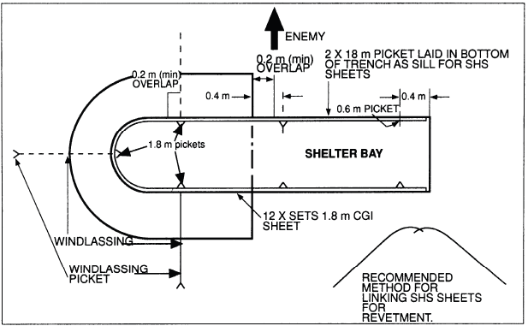

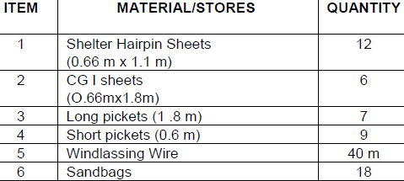 | Concealment  a. the use of camouflage netting or covers at all times;  b. changing foliage as soon as it withers;  c. selection of good thermal background or cover for heat generating  equipment, such as vehicle engines, generators and stoves;  d. distribution of spoilage to avoid both ground and air detection;  e. careful selection of routes to OPs, sentry posts, platoon and company  HQs and administrative areas; and  f. adherence to the track plan.

Defendable. Position is defined as defendable when all trenches are dug to stage 1 and the Direct Fire Plan, Defensives Fire Plan, and Countermoves Plan are completed and communicated.

